How to Create a Lab Guide

Table of Contents
Create the Lab Guide 3
Write Your Lab Guide Content in Word (or another program) 3
Access the ‘My Content’ Tool in TILE Composer 3
Copy Your Lab Guide Content into a New ‘Post’ 4
Map the Lab Guide to the Lab Activity 8
Media Tips 10
Lab Guide Templates 12
Template 1 – Simple Text 12
Template 2 – Text w/Media 13
Template 3 – Content Toggles 16
Template 4 –Tabs w/Content Toggles 20

Lab Guides are used in Virtual Lab activities to provide instructions and reference material for the learners, providing them with the information and guidance they’ll need to complete the lab. You can create your own lab guide for a Virtual Lab activity using the “My Content” feature in TILE Composer. Follow the instructions below to build your own guide.

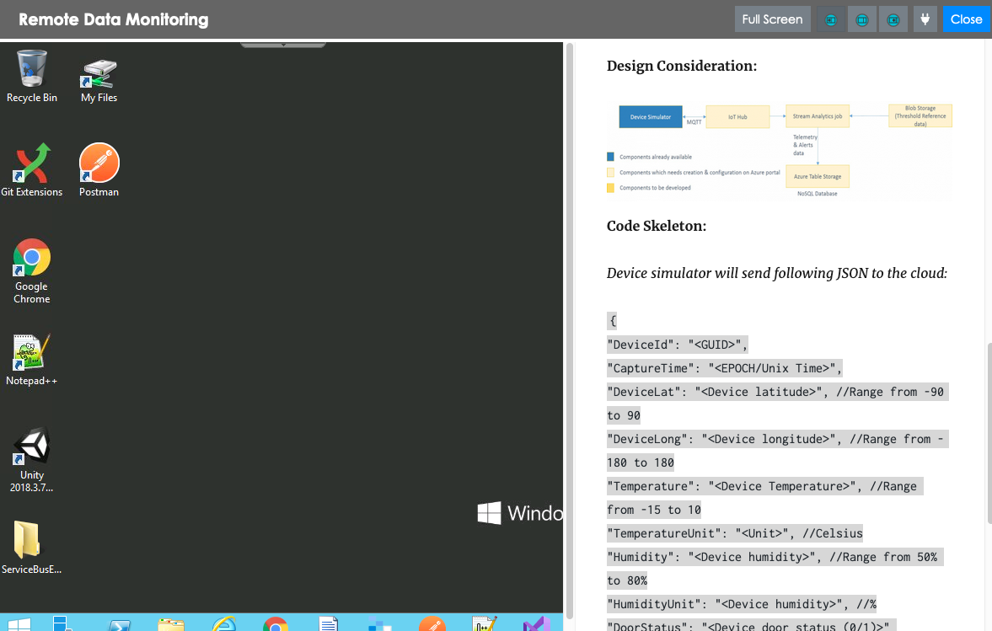

Create the Lab Guide

Write Your Lab Guide Content in Word (or another program)
1. Select one of these links to choose a “Starter Content” template for your lab guide, then use it to write and format your lab guide content:

- Starter Template #1 – Simple Text
- Starter Template #2 – Text w/Media
- Starter Template #3 – Content Toggles
- Starter Template #4 – Tabs w/Content Toggles

2. When you are finished writing your lab guide, select and copy all of the content to your device’s clipboard.

Access the ‘My Content’ Tool in TILE Composer
1. Login to TILE (https://dcm.toolwire.com/alai/portal/index.jsp)
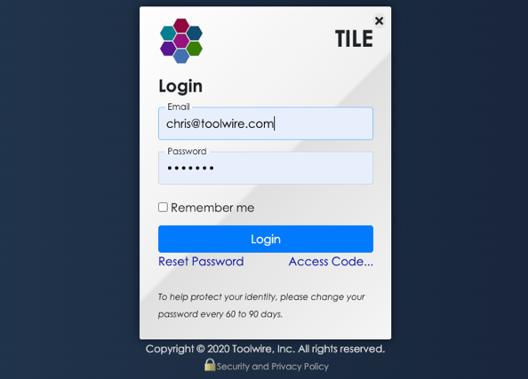

2. Access TILE Composer by selecting Composer at the top of the TILE interface. “Composer” is the Admin area of TILE.
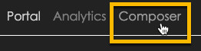

(NOTE: If you do not see the ‘Composer’ option, you may need to switch to a TILE profile that has administrative rights. Select the Profiles option in the side menu, then select the appropriate TILE profile.)
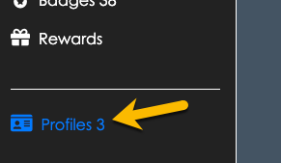

3. TILE Composer displays. Next, select the My Content option in the side menu.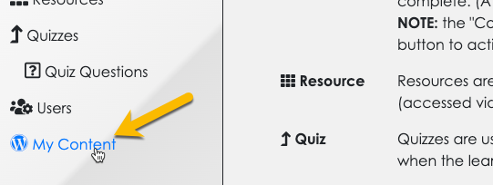

4. The My Content interface displays. You can use this tool to create lab guides, as well as to upload images and other media. (NOTE: This tool is attached to your TILE user profile, which means the content you add here is only visible to you until you decide to share it with others.)
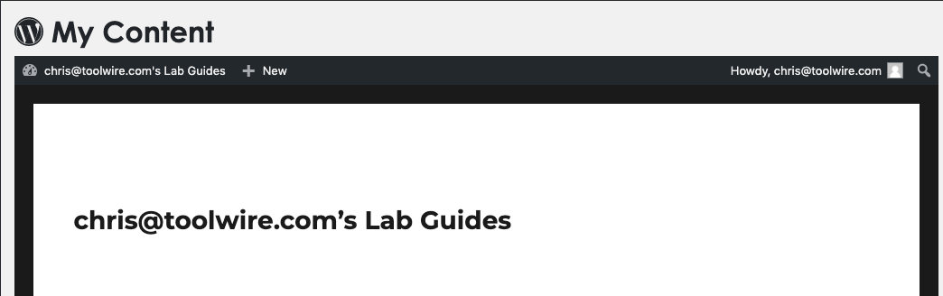

Copy Your Lab Guide Content into a New ‘Post’
1. Click + New at the top of the My Content interface, and then select the Post option.
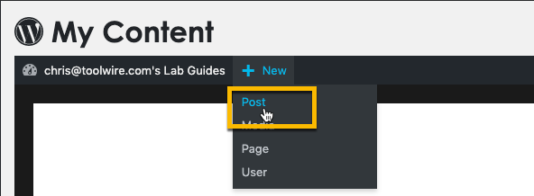

2. The ‘Write Post’ interface displays. Enter a Title for your new lab guide.
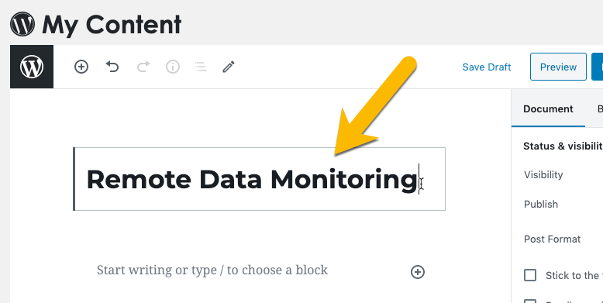

3. Select the ‘block’ located below the lab guide title. Then Paste the lab guide content that you copied earlier in your Word (or other) program.
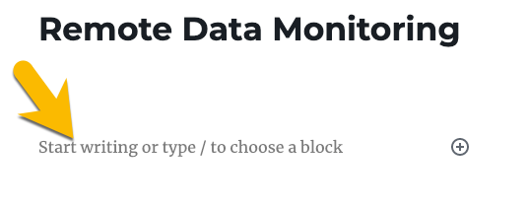
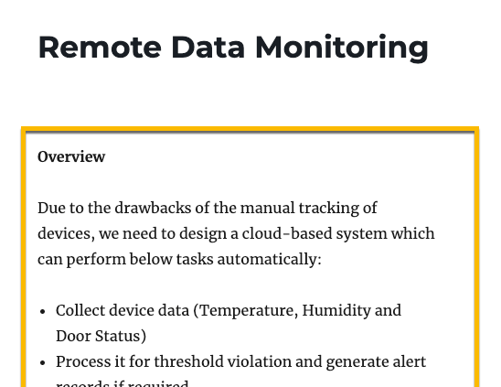

4. Select Save Draft.
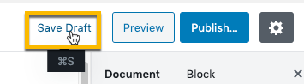

5. Review the lab guide content you pasted into the post and make updates as needed:

- Grammar and typos
- Text style (bold, italics, etc.) and color

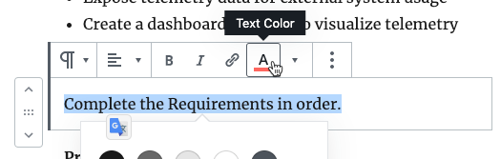

6. If you have any code snippets in your content, just select the text for the code and then select the Inline Code option in the content properties.
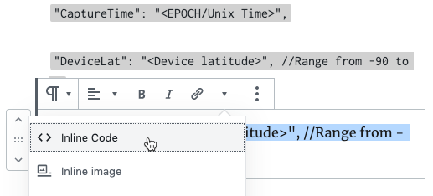

Alternatively, you can add a new block (by clicking the + button, then selecting Code). Then copy/paste your code text into the new code field.
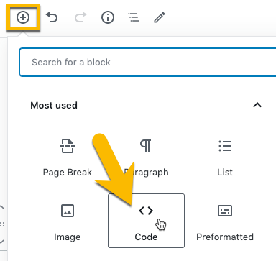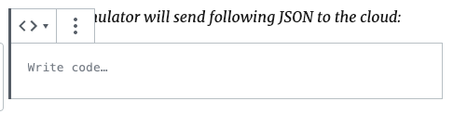

7. If you copy/pasted any images or other types of media, you will be prompted to upload or provide a link to these files. (Refer to the “Media Tips” section further down in this document for more guidance on adding media to your lab guide.)
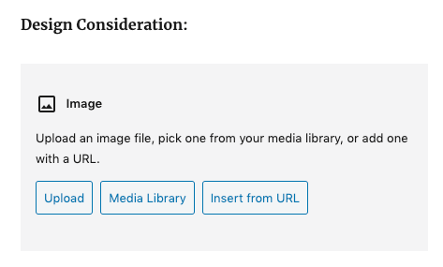

8. Save the post again. Then select the Preview button to see what your lab guide looks like in a browser.
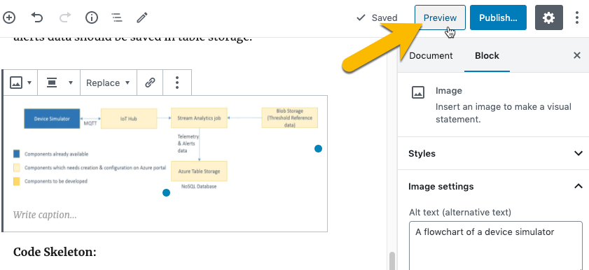

9. Continue to adjust your content and formatting, as needed, until the lab guide is finished. Then select the Publish button at the top of the post.
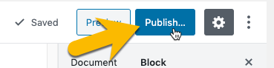

An “Are you ready to publish?” message appears. Leave the settings as they are and click Publish again.
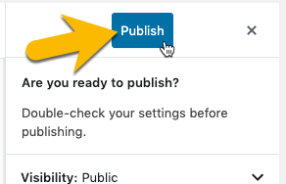

10. A message displays, confirming that your new lab guide is now published and available. Select the Copy Link button to copy the URL for your new lab guide. You will use this link in the next section of instructions to “connect” your lab guide to the virtual lab guide activity.
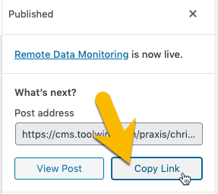

Map the Lab Guide to the Lab Activity

Navigate to the Lab Resource in TILE Composer

1. Select Resources in the side menu.
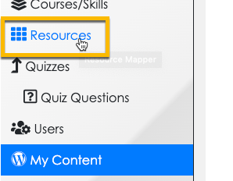

2. The Resources page opens. Use the breadcrumb links to make sure you are in the right course/skill. Then select the Lab Resource you want to attach your new lab guide to.
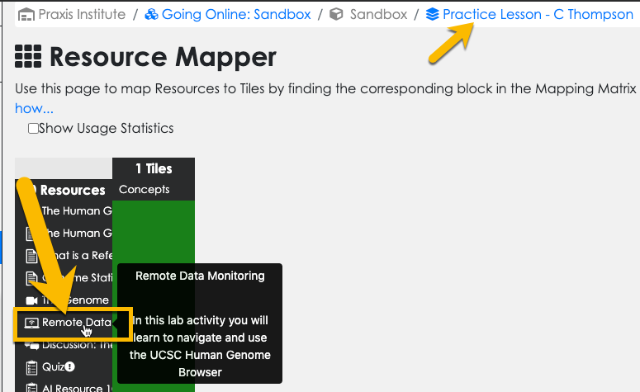

3. The Settings Panel for the lab resource opens. (Make sure to click the ‘Lock & Edit’ button at the top of the Composer interface, if you haven’t already.) Paste the link you copied for the lab guide post in My Content into the URL/Filename field. Then click Save.
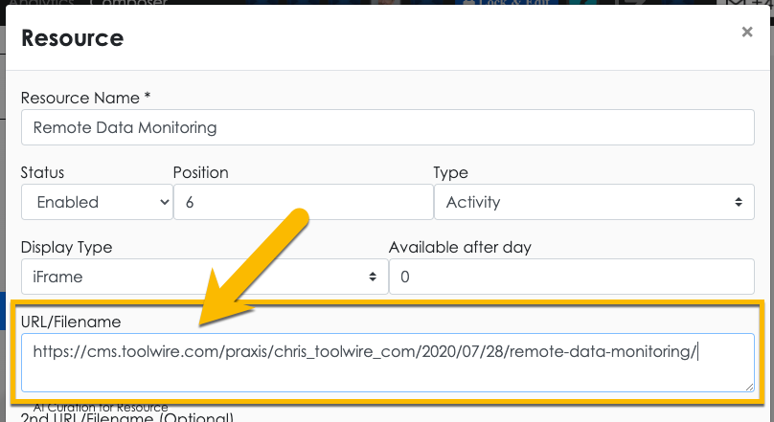

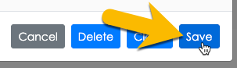

4. Your lab guide is now attached to the Virtual Lab activity. To make sure the lab guide is displaying properly, select Portal at the top of the screen, then navigate to the Virtual Lab and launch it.

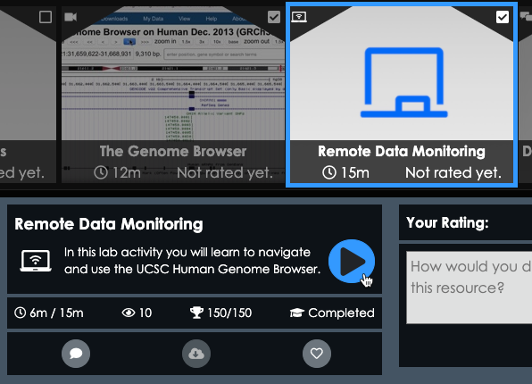

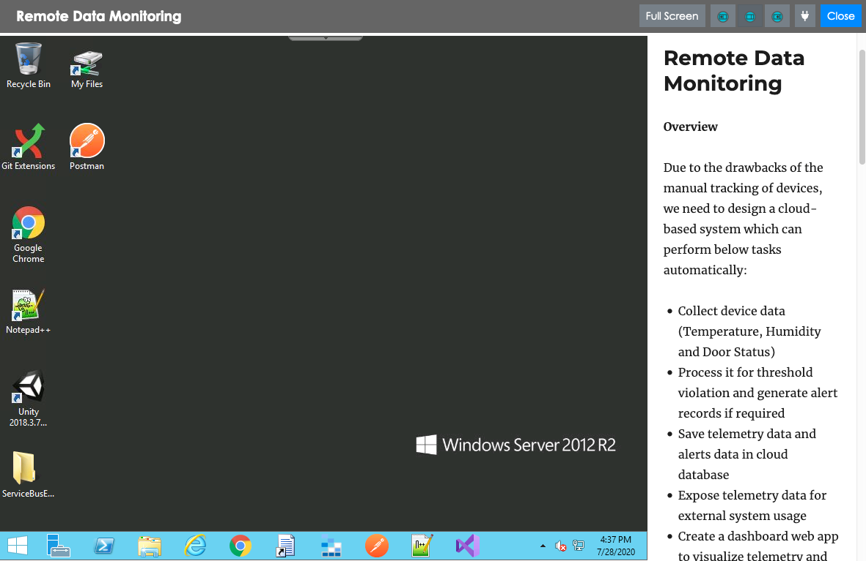

Media Tips

1. Upload an Image to a Placeholder Copy/Pasted from Word
Use the Upload, Media Library, or Insert from URL options and follow the resulting prompts:
2. Add a New Media Element to Lab Guide in My Content
a. Add a new ‘Block’ to the post by clicking the +add option at the top of the interface, or in-line with the lab guide content:
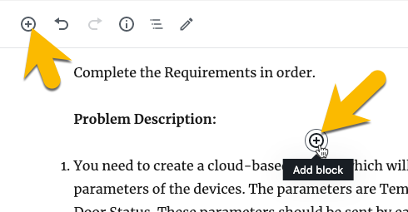

b. The ‘Block Settings’ panel opens. Select the Common Blocks category, then the media type you want to add. Then follow the resulting prompts to upload the media file or insert from URL.
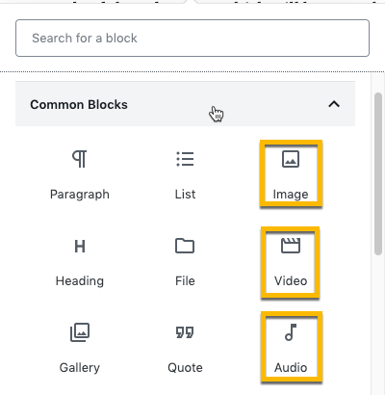

c. Alternatively, you can also select the Embeds category to embed media from popular web-based sources.
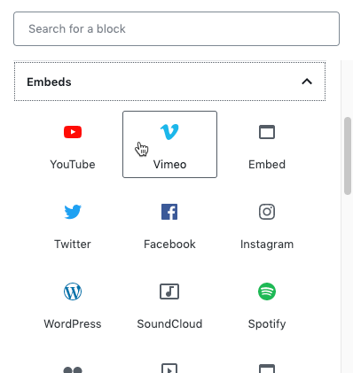

Adding Content Toggles and Tabs
If you have a lot of content for your lab guide, you may want to use Content Toggles and/or Tabs to make it easier for the learner to navigate. (NOTE: These elements are included in Lab Guide Templates 3 and 4.)

Add a Content Toggle

1. Select the +Add block button as you would for any other lab guide element.
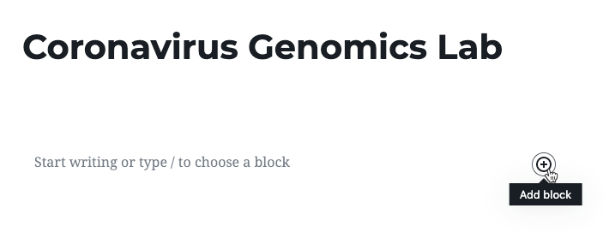

2. Type ‘content’ into the search box, then select the Content Toggle option.
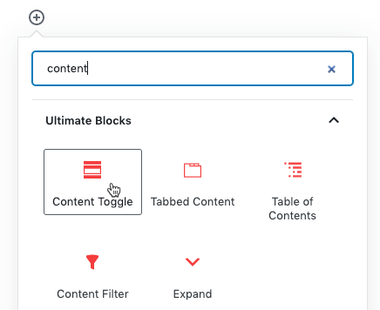

3. A content panel is added. Add a title to the new panel heading. (When the user clicks this heading, the panel will expand/collapse.)
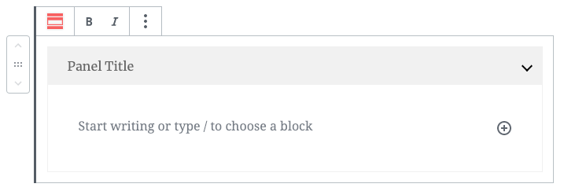
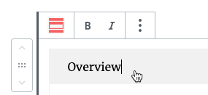

4. You can customize the color of the panel container using the control menu on the right side of the screen.
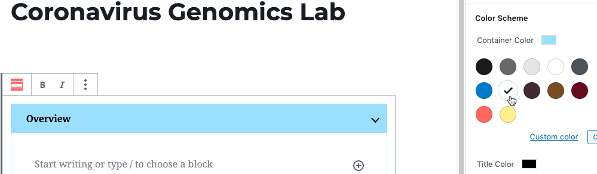

5. Next, write/copy in the content for the panel. To add a new panel below the current one, just click the + button at the bottom of the panel. (You can click the + button at the top to add a new panel above.)
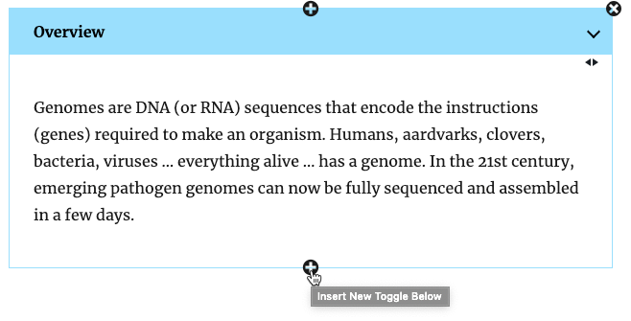

6. You can control the expand/collapse behavior of the panels by changing the settings in the Initial State panel at the right side of the screen.
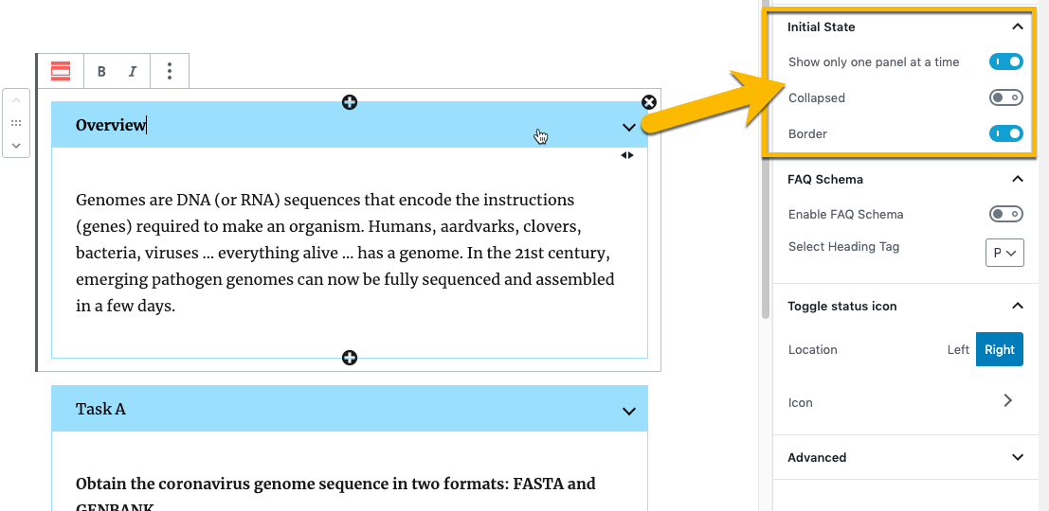

Add a Tab

1. Select the +Add block button as you would for any other lab guide element. Then type ‘tabbed’ into the search box, then select the Tabbed Content option.
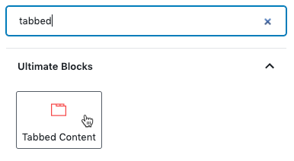

2. The new Tab element is added. Click directly on a tab to give it a title. Click the + tab button to add a new tab.
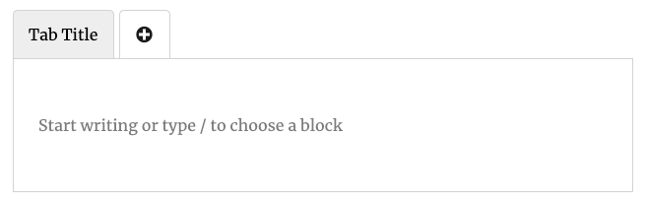
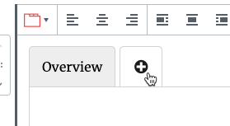

3. Use the Tab Colors controls at the right side of the screen to adjust the color of the tabs.
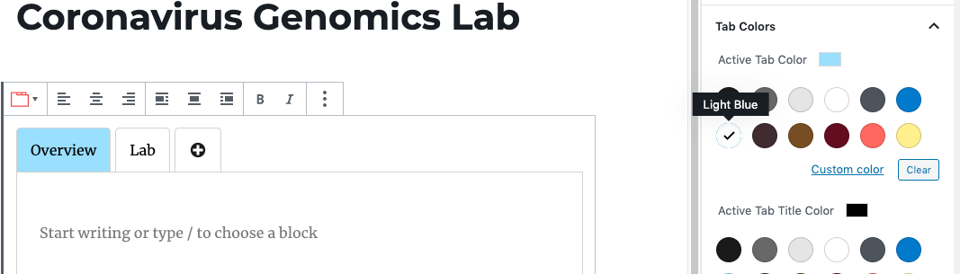

4. To add content inside of a tab, just click the +Add block button as you normally would. You can add any type of content within a tab, including a Content Toggle (or even another Tab element).
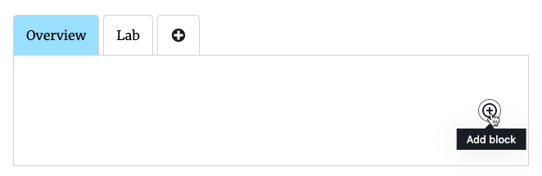

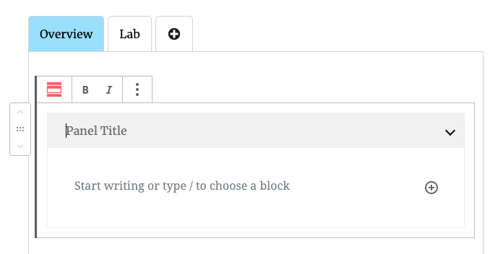

Lab Guide Templates

Template 1 – Simple Text
Instructions: Update the content below with the content for your lab. (You can write the content directly in this Word document, or write it in a separate Word file or another program.) When you are finished writing your lab guide, select and copy all of the content to your device’s clipboard.

Heading

Overview text…

Follow these step-by-step instructions:

- Instructions for step 1...
- Instructions for step 2…
- Detailed instructions about this step…
- More detailed instructions about this step…

- Instructions for step 3…

NOTE: Special information about this step that needs to be emphasized…

- Instructions for step 4…
- Instructions for final step of the lab guide…

[Go back up to Lab Guide Instructions]

Sample Content for this Lab Guide Type
Here’s some sample content for this type of Lab Guide:

Linux Command Line

Follow these lab instructions:

- Start the Praxis Cloud Desktop to access the Linux Operating System (OS).
- Click on your home directory in the Graphical User Interface (GUI).
- What directories are inside this directory?
- Look inside the directories. What files are in there? Don’t be shy.

- Open the terminal so you can access the Linux Command Line Interface (CLI).
- Instead of clicking icons representing files and apps in a GUI, one types text commands in the CLI. This may be awkward at first, but soon you will see the power in the CLI’s flexibility. Type some Linux commands in the CLI.

NOTE: Linux is case sensitive so uppercase and lowercase letters are different.

- Is -> This command is a Linux program (aka app or binary) that lists files and directories. Note: In Linux, you usually start in your home directory named after your username. For example ‘\home\student’ is the home directory for the user ‘student’.
- pwd -> This command shows you at the present working directory. Note that the root of the filesystem begins with ‘\’ so one can ‘cd\’.

NOTE: When we show single quotes around a command line, do not type the quotes in the CLI.

Template 2 – Text w/Media
Instructions: Update the content below with the content for your lab. (You can write the content directly in this Word document, or write it in a separate Word file or another program.) When you are finished writing your lab guide, select and copy all of the content to your device’s clipboard.

Heading

Overview text…

Step-by-step instructions:

- Instruction for step 1, including an image...

- Instruction for step 2…
- Detailed instructions about this step…
- More detailed instructions about this step…

- Instruction for step 3…

NOTE: Special information about this step that needs to be emphasized…

- Instruction for step 4, including a reference table…
Heading 1 | Heading 2 | Heading 3
Cell 1 text… | Cell 2 text… | Cell 3 text…

- Instruction for step 5, including a code snippet…

- Instruction for step 6, including a video…
[video filename or link to video hosted online]

- Instruction for final step of the lab guide…

[Go back up to Lab Guide Instructions]

Sample Content for this Lab Guide Type
Here’s some sample content for this type of Lab Guide:

Remote Data Monitoring

Overview

Due to the drawbacks of the manual tracking of devices, we need to design a cloud-based system which can perform below tasks automatically:

- Collect device data (Temperature, Humidity and Door Status)
- Process it for threshold violation and generate alert records if required
- Save telemetry data and alerts data in cloud database
- Expose telemetry data for external system usage
- Create a dashboard web app to visualize telemetry and alerts data

Complete the Requirements in order.

Problem Description:
- You need to create a cloud-based system which will keep track of various parameters of the devices. The parameters are Temperature, Humidity and Door Status. These parameters should be sent by each device to the cloud after a specific interval (ex. after each 20 seconds). On cloud, process only temperature data against predefined thresholds from blob storage.
- Rest of the parameters data should be directly added to Table Storage without threshold checking. Alert records should be generated if any threshold is violated for temperature value. All the telemetry & alerts data should be saved in table storage.

Design Consideration:
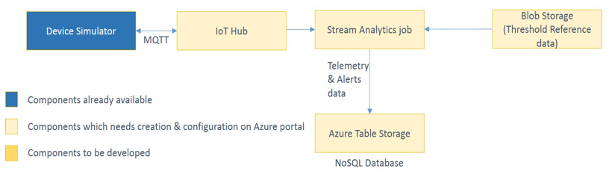

Code Skeleton:

Device simulator will send following JSON to the cloud:

{
"DeviceId": "<GUID>",
"CaptureTime": "<EPOCH/Unix Time>",
"DeviceLat": "<Device latitude>", //Range from -90 to 90
"DeviceLong": "<Device longitude>", //Range from - 180 to 180
"Temperature": "<Device Temperature>", //Range from -15 to 10
"TemperatureUnit": "<Unit>", //Celsius
"Humidity": "<Device humidity>", //Range from 50% to 80%
"HumidityUnit": "<Device humidity>", //%
"DoorStatus": "<Device door status (0/1)>" //Possible values true/false
}

Actual simulator output json:

{
"TemperatureUnit":"Celsius",
"HumidityUnit":"%",
"DeviceId":"d4aea4d2-2c97-4e2c-9d12-036e9a0c52c0",
"CaptureTime":1522250154,
"DeviceLat":0.0,
"DeviceLong":0.0,
"Temperature":4.0248263856,
"Humidity":52.0,
"DoorStatus":false
}

Template 3 – Content Toggles
Instructions: This template includes ‘content toggles,’ which are expandable/collapsible sections you can organize your content into. Update the content below with the content for your lab. (You can write the content directly in this Word document, or write it in a separate Word file or another program.) When you are finished writing your lab guide, select and copy the content – section by section – to your device’s clipboard.

Heading

Toggle 1 (expanded by default)

Subheading A

Content…

Follow these step-by-step instructions:

- Instructions for step 1...
- Instructions for step 2…

Toggle 2

Subheading B

Content…

Follow these step-by-step instructions:

- Instructions for step 1...
- Instructions for step 2…

Toggle 3

Subheading C

Content…

Follow these step-by-step instructions:

- Instructions for step 1...
- Instructions for step 2…

[Go back up to Lab Guide Instructions]

Sample Content for this Lab Guide Type
Here’s some sample content for this type of Lab Guide:

Coronavirus Genomics Lab

Toggle 1 (expanded by default)

Overview

Genomes are DNA (or RNA) sequences that encode the instructions (genes) required to make an organism. Humans, aardvarks, clovers, bacteria, viruses … everything alive … has a genome. In the 21st century, emerging pathogen genomes can now be fully sequenced and assembled in a few days.
Once we know the pathogen’s genome sequence, we can develop diagnostics tests, therapeutics, vaccines, and study the pathogen’s biology. Never in history has this biotechnology been so rapid! For example, here is a viral pathogen called the coronavirus that was sequenced in 2019:

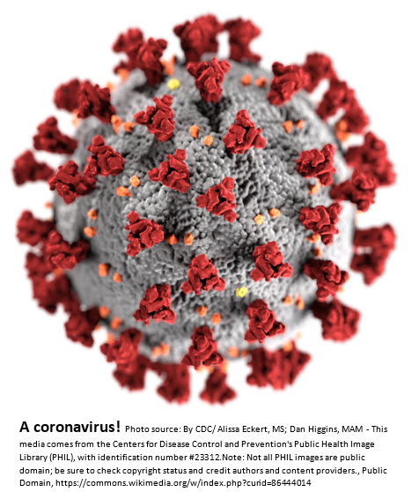

Toggle 2

Task A

Obtain the coronavirus genome sequence in two formats: FASTA and GENBANK.
Step 1: Download the coronavirus genome sequence in FASTA format from NCBI (MN908947.3) and store in a text file called MN908947.fasta. Step 2: Obtain the coronavirus genome sequence in GENBANK format from NCBI (MN908947.3) by copying the GENBANK sequence starting with the word ‘LOCUS’ and ending with the double slash ‘//’ and pasting into a text file called MN908947.genbank.

Toggle 3

Task B

Cut out the all of the coronavirus gene subsequences from the full genome and save in a file.
Step 1: In a Jupyter notebook, write Python code that reads the GENBANK formatted coronavirus genome DNA sequence file from task A, parses the coordinates of all CDS gene subsequences, and stores those values in a Python dictionary.

Pseudocode:
Open and load the GENBANK-format genome file
Loop through each line of the file {
For each gene {
Extract the gene name and CDS coordinates and store in a dictionary where the key is the gene_name and the values are the CDS coordinates

}DataByte:
For example, here is the first gene ‘orf1ab’ from the GENBANK file with two sets CDS coordinates (266..13468,13468..21555). CDS coordinates might have a gap so two subsequences would need to be joined to get the full CDS subsequence:

gene 266..21555

/gene=”orf1ab”

CDS join(266..13468,13468..21555)

}Step 2:In a Jupyter notebook, write Python code that reads the FASTA formatted coronavirus genome DNA sequence file from task A, cuts out the actual sequences from the FASTA file using the dictionary from Task B (Step 1), and writes a text file called that contains with all of the coronavirus CDS DNA sequences in a single concatenated DNA file.

Pseudocode:
Open and load the FASTA-format genome file
Loop through all of the genes in your coordinate dictionary from step 1{
Write the gene name to an output file starting with the ‘>’ FASTA delimiter
Cut the CDS DNA subsequence of the genome from the FASTA file (join CDS substrings if necessary) and append to the output file

}Notes:
- All the gene sequences are now in the same file that can be parsed using lines that start with the FASTA ‘>’ delimiter.
- A string of triplet codons in RNA is called the protein codon sequence (CDS) – See BioBytes. If you look in the GENBANK file above the actual sequence
- The CDS DNA sequences are in the GenBank file, so you can check the accuracy of your sequence extraction.

Toggle 4

Task C

Transcribe all of the genes from DNA into RNA.
In a Jupyter notebook, write Python code that transcribes all DNA CDS sequences into single concatenated RNA sequence file in FASTA format.

Pseudocode:
Open and load the CDS FASTA DNA file from Task B
For each sequence {
Write the line that starts with ‘>’ to an output file
Use a dictionary to convert all ‘T’ bases to ‘U’ and make all bases uppercase
Write the transcribed RNA sequence to the output file

}DataByte:
For example, the beginning of the first gene ‘orf1ab’ would be transcribed from

>orf1lab (DNA)

ATGGAGAGCCTTGTC…into

>orf1lab (RNA)

AUGGAGAGCCUUGUC…

Toggle 5

Task D

Translate all of the genes from RNA into PROTEIN.
In a Jupyter notebook, write Python code that translates all DNA CDS sequences into single concatenated PROTEIN sequence file in FASTA format.

Pseudocode:
Open and load the FASTA RNA file from Task C
For each sequence {
Write the line that starts with ‘> GeneName’ to an output file
Use a Python dictionary to translate all three character codons to amino acid codes
Write the transcribed RNA sequence to the output file

}DataByte:
For example, the beginning of the first gene ‘orf1ab’ would be translated from

>orf1lab (RNA)

AUGGAGAGCCUUGUC…into

>orf1lab (PROTEIN)

MESLV…Notes:
- The protein sequences are in the GenBank file, so you can check the accuracy of your sequence extraction.
- Check out the CodeBytes section for help with the genetic code dictionary.
- Stop codons do not code for an amino acid. The penultimate codon would be the last amino acid.

Template 4 –Tabs w/Content Toggles
Instructions: This template includes ‘content toggles’ and tabs - which provide another level of navigation for lab guides with in-depth content. Update the content below with the content for your lab. (You can write the content directly in this Word document, or write it in a separate Word file or another program.) When you are finished writing your lab guide, select and copy the content – section by section – to your device’s clipboard.

Heading
Tab 1 (selected by default)

Tab Label A

Toggle 1 (expanded by default)

Subheading A

Content…

Follow these step-by-step instructions:

- Instructions for step 1...
- Instructions for step 2…

Toggle 2

Subheading B

Content…

Follow these step-by-step instructions:

- Instructions for step 1...
- Instructions for step 2…

Tab 2

Tab Label B

Toggle 1 (expanded by default)

Subheading A

Content…

Follow these step-by-step instructions:

- Instructions for step 1...
- Instructions for step 2…

Toggle 2

Subheading B

Content…

Follow these step-by-step instructions:

- Instructions for step 1...
- Instructions for step 2…

[Go back up to Lab Guide Instructions]

Sample Content for this Lab Guide Type
Here’s some sample content for this type of Lab Guide:

Coronavirus Genomics Lab
Tab 1 (selected by default)

Overview

Toggle 1 (expanded by default)

Coronavirus Genomics Lab Overview

Background: Genomes are DNA (or RNA) sequences that encode the instructions (genes) required to make an organism. Humans, aardvarks, clovers, bacteria, viruses … everything alive … has a genome. In the 21st century, emerging pathogen genomes can now be fully sequenced and assembled in a few days.
Once we know the pathogen’s genome sequence, we can develop diagnostics tests, therapeutics, vaccines, and study the pathogen’s biology. Never in history has this biotechnology been so rapid! For example, here is a viral pathogen called the coronavirus that was sequenced in 2019:

Toggle 2

SuperLab Objectives

In this lab, you will download a coronavirus genome and write Python code that:
- Extracts the coronavirus genes from the full genome file as DNA sequences
- Transcribes the DNA sequences into RNA sequences
- Translates the RNA sequences into protein sequences

Tab 2

CodeBytes

Toggle 1 (expanded by default)

What is a CodeByte?

Here are useful Python code pieces that will help you in this lab. Remember that programming is a language are there are many code paths to achieve the same goal so try out other solutions!
Toggle 2

Open and Read a File in Python

CodeByte: How to open a file, read all the lines, and close a file a Linux filesystem:
infile = open(“/home/student/directory/filename”, “r”)
lines = infile.readlines()
infile.close()

Toggle 3

Open and Write to a File in Python

CodeByte: How to open a file, write data to the file, and close a file a Linux filesystem:
outfile = open(“/home/student/directory/filename”, “, “w+”)
for line in lines:
outfile.write(line)outfile.close()

Toggle 4

Remove a Newline Character

CodeByte: Text files end in a newline character that is often not displayed. One can remove a newline character from a line of like this:
line = line.rstrip(‘\n’)

Toggle 5

Python Single-Letter Replacement Dictionary

CodeByte: Transcription dictionary (Plus change lowercase to UPPERCASE):
dna2rna = {“A”:”A”, “T”:”U”, “G”:”G”, “C”:”C”, “N”:”N”, “a”:”A”, “t”:”U”, “g”:”G”, “c”:”C”, “n”:”N”}

Toggle 6

Python Multiple-Letter Replacement Dictionary

Codebyte: The standard genetic code in a Python dictionary:
Below is the full genetic code in the form of a Python dictionary. Note that some amino acids are coded by multiple codons. Also, ‘AUG’ typically is the first codon in an RNA so most proteins begin with M as the first amino acid. Three other codons do not code for amino acids but signal the end of translation. These codons are called stop codons and include ‘UGA’, ‘UAA’, and ‘UAG’.

rna2protein = {“UUU”:”F”, “UUC”:”F”, “UUA”:”L”, “UUG”:”L”,
“UCU”:”S”, “UCC”:”S”, “UCA”:”S”, “UCG”:”S”,
“UAU”:”Y”, “UAC”:”Y”, “UAA”:””, “UAG”:””,
“UGU”:”C”, “UGC”:”C”, “UGA”:””, “UGG”:”W”,
“CUU”:”L”, “CUC”:”L”, “CUA”:”L”, “CUG”:”L”,
“CCU”:”P”, “CCC”:”P”, “CCA”:”P”, “CCG”:”P”,
“CAU”:”H”, “CAC”:”H”, “CAA”:”Q”, “CAG”:”Q”,
“CGU”:”R”, “CGC”:”R”, “CGA”:”R”, “CGG”:”R”,
“AUU”:”I”, “AUC”:”I”, “AUA”:”I”, “AUG”:”M”,
“ACU”:”T”, “ACC”:”T”, “ACA”:”T”, “ACG”:”T”,
“AAU”:”N”, “AAC”:”N”, “AAA”:”K”, “AAG”:”K”,
“AGU”:”S”, “AGC”:”S”, “AGA”:”R”, “AGG”:”R”,
“GUU”:”V”, “GUC”:”V”, “GUA”:”V”, “GUG”:”V”,
“GCU”:”A”, “GCC”:”A”, “GCA”:”A”, “GCG”:”A”,
“GAU”:”D”, “GAC”:”D”, “GAA”:”E”, “GAG”:”E”,
“GGU”:”G”, “GGC”:”G”, “GGA”:”G”, “GGG”:”G”}

Tab 3

Lab

Toggle 1 (expanded by default)

Task A

Obtain the coronavirus genome sequence in two formats: FASTA and GENBANK.
Step 1: DDownload the coronavirus genome sequence in FASTA format from NCBI (MN908947.3) and store in a text file called MN908947.fasta. Step 2: Obtain the coronavirus genome sequence in GENBANK format from NCBI (MN908947.3) by copying the GENBANK sequence starting with the word ‘LOCUS’ and ending with the double slash ‘//’ and pasting into a text file called MN908947.genbank.

Toggle 2

Task B

Cut out the all of the coronavirus gene subsequences from the full genome and save in a file.
Step 1: In a Jupyter notebook, write Python code that reads the GENBANK formatted coronavirus genome DNA sequence file from task A, parses the coordinates of all CDS gene subsequences, and stores those values in a Python dictionary.

Pseudocode:
Open and load the GENBANK-format genome file
Loop through each line of the file {
For each gene {
Extract the gene name and CDS coordinates and store in a dictionary where the key is the gene_name and the values are the CDS coordinates

}DataByte:
For example, here is the first gene ‘orf1ab’ from the GENBANK file with two sets CDS coordinates (266..13468,13468..21555). CDS coordinates might have a gap so two subsequences would need to be joined to get the full CDS subsequence:

gene 266..21555

/gene=”orf1ab”

CDS join(266..13468,13468..21555)

}Step 2:In a Jupyter notebook, write Python code that reads the FASTA formatted coronavirus genome DNA sequence file from task A, cuts out the actual sequences from the FASTA file using the dictionary from Task B (Step 1), and writes a text file called that contains with all of the coronavirus CDS DNA sequences in a single concatenated DNA file.

Pseudocode:
Open and load the FASTA-format genome file
Loop through all of the genes in your coordinate dictionary from step 1{
Write the gene name to an output file starting with the ‘>’ FASTA delimiter
Cut the CDS DNA subsequence of the genome from the FASTA file (join CDS substrings if necessary) and append to the output file

}Notes:
- All the gene sequences are now in the same file that can be parsed using lines that start with the FASTA ‘>’ delimiter.
- A string of triplet codons in RNA is called the protein codon sequence (CDS) – See BioBytes. If you look in the GENBANK file above the actual sequence
- The CDS DNA sequences are in the GenBank file, so you can check the accuracy of your sequence extraction.

Toggle 3

Task C

Transcribe all of the genes from DNA into RNA.
In a Jupyter notebook, write Python code that transcribes all DNA CDS sequences into single concatenated RNA sequence file in FASTA format.

Pseudocode:
Open and load the CDS FASTA DNA file from Task B
For each sequence {
Write the line that starts with ‘>’ to an output file
Use a dictionary to convert all ‘T’ bases to ‘U’ and make all bases uppercase
Write the transcribed RNA sequence to the output file

}DataByte:
For example, the beginning of the first gene ‘orf1ab’ would be transcribed from

>orf1lab (DNA)

ATGGAGAGCCTTGTC…into

>orf1lab (RNA)

AUGGAGAGCCUUGUC…

Toggle 4

Task D

Translate all of the genes from RNA into PROTEIN.
In a Jupyter notebook, write Python code that translates all DNA CDS sequences into single concatenated PROTEIN sequence file in FASTA format.

Pseudocode:
Open and load the FASTA RNA file from Task C
For each sequence {
Write the line that starts with ‘> GeneName’ to an output file
Use a Python dictionary to translate all three character codons to amino acid codes
Write the transcribed RNA sequence to the output file

}DataByte:
For example, the beginning of the first gene ‘orf1ab’ would be translated from

>orf1lab (RNA)

AUGGAGAGCCUUGUC…into

>orf1lab (PROTEIN)

MESLV…Notes:
- The protein sequences are in the GenBank file, so you can check the accuracy of your sequence extraction.
- Check out the CodeBytes section for help with the genetic code dictionary.
- Stop codons do not code for an amino acid. The penultimate codon would be the last amino acid.

